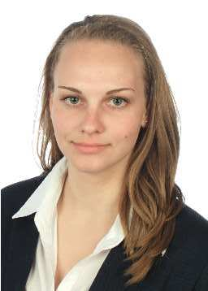
Personal information
Name and surname: Monika Vaňková
Date of birth: 31. 12. 1992
Address: Prague 6
Family status: single
Phone number: 721 113 745
E-mail: monika-vankova@centrum.cz
Achieved education
2012 – continuing University of Economics in Prague – field of study – Corporate finance and management
2004 – 2012 grammar school Nad Alejí 1952 in Prague 6
Work experience
10/2014 – continuing Internship in tax department in TPA Horwath Tax s.r.o. Orientation on CIT, tax return preparation, tax calculation and verifying of bookkeeping correctness, tax Due Dilligence, cooperation with forming of transfer-pricing documentation
2 – 3/2014 Data archiving and seeking from land register for Arcibiskupství pražské
2013 – continuing German translation for KB model
2012 – continuing German interpreter for a company MTB-model, product presentation in a trade fair in Lipsko
7/2011 Administrative work in CDMB and inventory of consumer material in ČEPS, a.s.
Languages and other skills
Languages:
English – fluently spoken and written, certificate FCE
German – fluently spoken and written
Spanish – intermediate level
French – basic level
Other skills:
Work on computer (MS Office – Word, Excel, Power Point, Lotus Notes, FORM Studio)
Driving license group B
Good communication skills and sense for detail and accuracy
Interests:
Music and singing, playing the piano, sport, travelling

